MEEG333 FLUIDS LABORATORY

X1. Hydrostatic Force and Center of Pressure on Submerged Surface

Objectives

To observe and measure the hydrostatic force on a submerged plane surface

Calculate experimental uncertainty between measurement and theory

Design Objective: Use theory to answer a practical fluid statics problem.

Apparatus

The toroidal device to be used is sketched below. See also Figure D2.2, pg 136 (7th ed.) in the textbook.

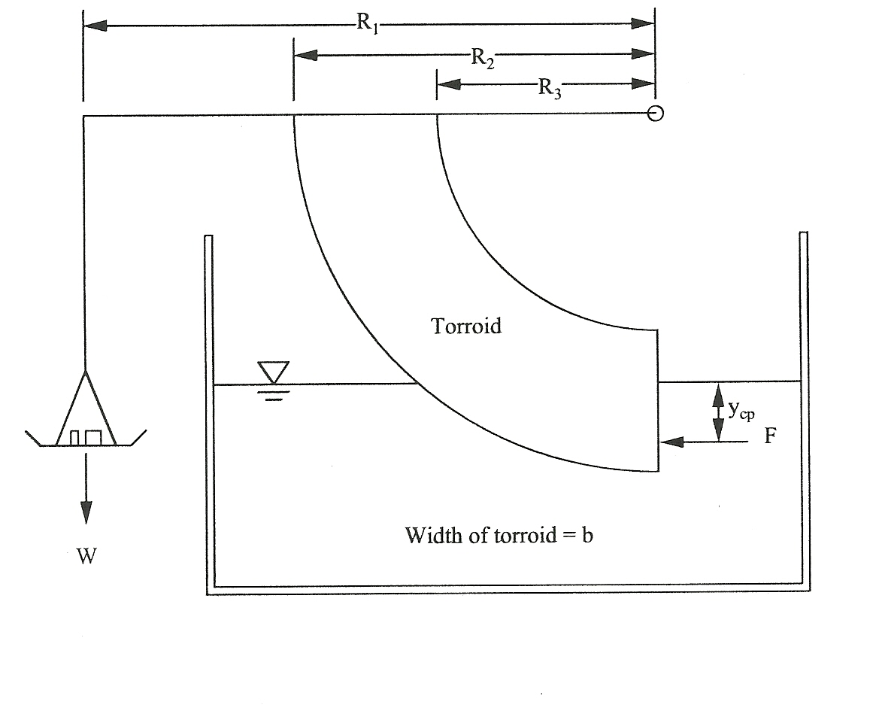

Theory

The fluid pressure is “hydrostatic” when the fluid is stationary. The free surface elevation of the stationary fluid is horizontal. The hydrostatic pressure P at a point below the horizontal free surface is given by

P=gh + Patm

where  = density of the fluid, g = gravitational constant, h = vertical distance below the free surface, and Patm = atmospheric pressure, which can be taken to be zero if P is gage pressure.

The fluid pressure acts normal to the surface of an object and is positive in compression. The pressure is not uniform, but increases with depth according to the equation above. Integration of the pressure over a submerged surface yields the hydrostatic force F acting on the submerged surface. A resultant moment about a specific point can be obtained from the calculated force and its equivalent point of application, distance yCP below the surface.

See Equation 2.26 and Example 2.5 in the textbook for definition of yCP .

Procedure

The apparatus will measure the hydrostatic force by balancing it with weights placed in the pan at R1. The moment R1*W should equal the moment of the hydrostatic force about the pivot point O. Study the diagram and the apparatus to understand why this is true. We will vary the water depth from the top edge of the toroid to the bottom, and balance the changing hydrostatic force with varying weights in the pan.

1. Measure all of the dimensions shown on the diagram. You will vary and record the depth of submergence, h. The value of yCP changes with depth and will be calculated from your data.

2. First, with the tank empty, adjust the balance arm until it is horizontal as indicated by the level located on the top of the arm. (Why do you do this?)

3. Fill the tank with water until the water surface is level with the top edge of the toroid’s vertical face. Ensure that the arm is horizontal by adjusting the mass in the pan. Record the mass in the pan and the depth of the water over the vertical face of the toroid, h. This is your first data point.

4. Repeat this procedure to get 5 combinations of depth h and weight. For each data point allow some water to flow out of the tank and reduce the amount of mass in the pan until the balance arm is again level. (Aim for 5 roughly equal decrements in height. Suggestion: You may find it more convenient to fine-tune the water height rather than the mass, to center the level indicator bubble accurately. Use a cup to gently add small, controlled amounts of water).

5. Also record the water temperature during the experiment to determine the density (or specific weight).

Data Reduction

For each mass-height combination calculate the area of the submerged surface. Calculate the total force, and center of pressure ycp on the vertical plate.

For each mass-height combination calculate the moment Mf of the hydrostatic force about the pivot O. For the same data point calculate the moment Mw of the weight in the pan about O.

Plot Mf  versus Mw , including the 45o line which is the locus of Mf = Mw .

Calculate the average root mean square difference between your measured moments (with the weights) and your calculated forces moments (with water force). This is a simple measure of uncertainty. The word “uncertainty” can mean that you do not know which is exact.

Discussion

Review your Data Reduction and discuss reasons if data does not fall on the 45o line. Comment on why points tend to be above or below the line. You are looking for reasons for uncertainty in your measurements, hence uncertainty in predictions you might make for design purposes. (If all your points are on the line, you are either golden, or suspect!).

Design Objective question:

Multistory buildings present a design engineer with interesting challenges. The Christiana Towers Apartments on the Laird Campus are 17 stories tall. One story is approximately 3.2 meters tall. Assume that there are issues that UDel Facilites needs to solve.

Utility water is supplied from a water main under the street by the city of Newark. Water pressure in the main averages about 280 kPa. For proper function, water fixtures (sink faucets, shower heads, commodes) are designed for water pressures of about 140 kPa.

1. Given the street main pressure, how high above the basement will water rise in the vertical water supply pipe serving each floor (how many meters, how many stories)?
2. How many stories up can water rise and still have the required 140 kPa fixture pressure?

(If your answer is greater than 17, re-check your calculation).

1. One solution to provide water to upper story residents is a pump to boost up the street main pressure. (This is done in the Towers). Calculate the booster pump discharge pressure required to insure 140 kPa at the top floor, assuming the pump is in the basement.

Note: Providing a single pump with adequate discharge pressure will get water to the upper floors. However, the lower floor fixtures nearer the pump may now have a much higher supply pressure than desirable. There are solutions for this. Many buildings are higher than this one. Write a **Summary** letter to Facilities with your professional engineering advice.